EXPERIMENT :6

Demonstrate virtualization by Installing Type-2 Hypervisor in your device, create and configure VM image with a Host Operating system (Either Windows/Linux).

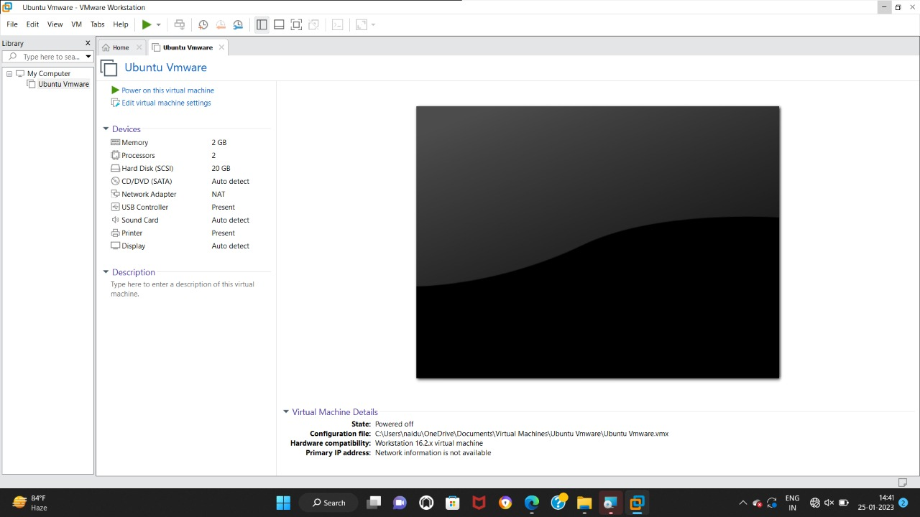

EXPERIMENT :7

Create a Virtual Machine with 1 CPU, 2GB RAM and 15GB storage disk using a Type 2 Virtualization Software.



EXPERIMENT :8

Create a Virtual Hard Disk and allocate the storage using VM ware Workstation

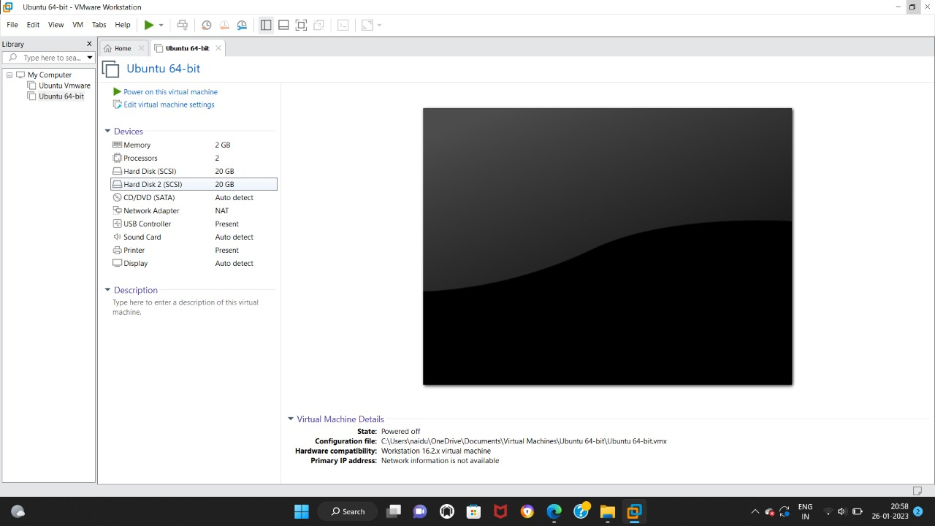

EXPERIMENT 9

Create a Snapshot of a VM and Test it by loading the Previous Version/Cloned VM

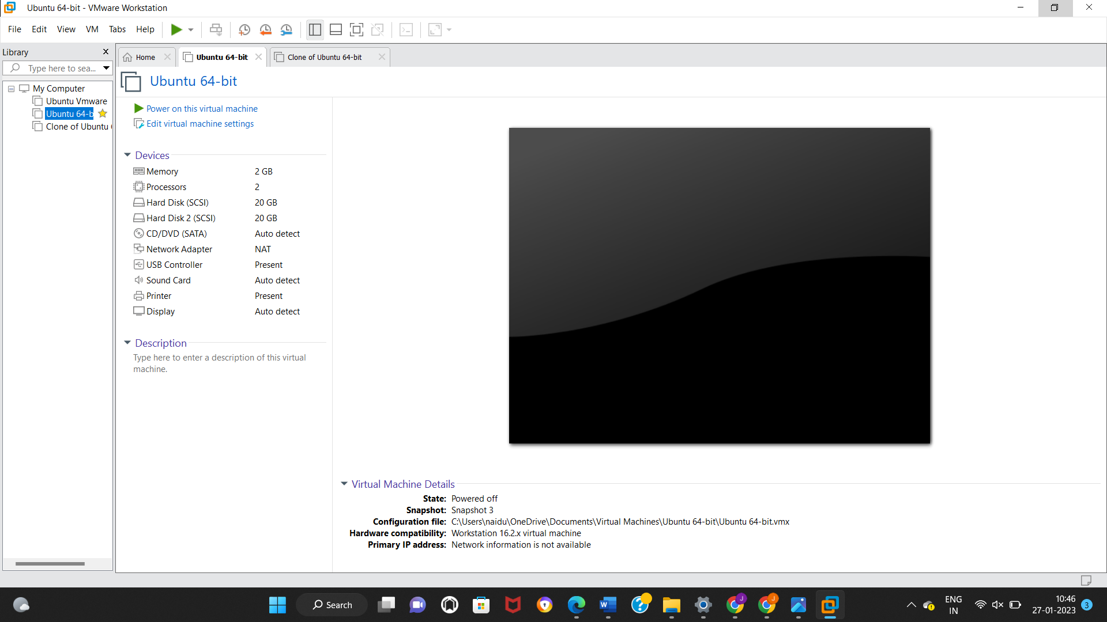

EXPERIMENT 10

Create a Cloning of a VM and Test it by loading the Previous Version/Cloned VM

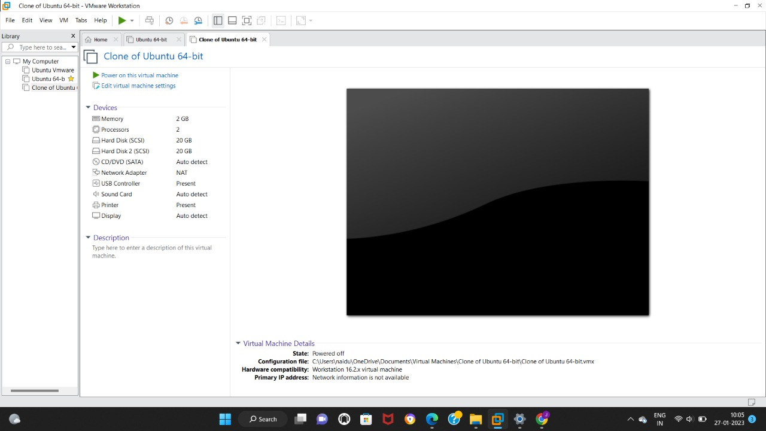

EXPERIMENT 11:

Change Hardware compatibility of a VM (Either by clone/create new one) which is already created and configured.

